**E-Commerce Website For Sporty Shoes**

This document contains sections for:

* **Sprint planning and Task completion****.**
* **[Technologies and Tools used in the project.](#_Core concepts used in the project:)**
* **[Core Concepts used in the project.](#_Core concepts used in the project:)**
* **The flow of the Application.**
* **Demonstrating the product capabilities, appearance, and user interactions.**
* **Unique Selling Points of the Application.**
* **Conclusions.**
* The code for this project is hosted at [**https://github.com/Dinesh123527/phase_3_project.**](https://github.com/Dinesh123527/phase_3_project)
* This project is developed by**Ashok Petel.**

## **Sprints planning and Task completion:**

The project is planned to be completed in 2 sprints. Tasks assumed to be completed in the sprint are:

**1st Sprint:**

* Creating the flow of the application.
* Initializing the git repository to track changes as development progresses.
* Creating a Spring Boot application to fulfill user requirements.
* Configure the Database to maintain the data used for the application.
* Adding the Required dependencies used for application.

**2nd Sprint:**

* Implemented the Model Layer and Service Layer for the project.
* Implemented Business Logic part.
* Creating API methods to fetch the response.
* Configure the API to check the Response of requested object.
* Testing in the Post-Man Tool to check whether the API methods are working or not by Response.

## **Core concepts used in the project:**

• Object-Oriented: used to create and model objects for users and their credentials.

• Databases: used to store and retrieve data.

• Data Sources: used to define a set of properties required to identify and access the database.

• Collections: used some collections such array-list to store collection of data.

• Collections: used Java8 Streams to filter and fetch collection of data.

• Custom Exception Handling: used to catch problems that arises in the code especially in I/O blocks.

• MVC: Micro Service is an architecture that allows the developers to develop and deploy services independently.

• Micro Services(Spring Boot): Micro Service is an architecture that allows the developers to develop and deploy services independently.

• API: API stands for application programming interface, which is a set of definitions and protocols for building and integrating application software.

## **Technologies and Tools used in the project:**

* **Spring Boot:** To create a E-commerce project for Sporty Shoes.
* **Postman:** To the API request and response.
* **H2 Database:** To create and manage the database.
* **JPA:** To manage the operations for the application.
* **Lombok:**It is the tool of the java library that was used to generate code for minimizing the unused code.
* **Rest-API:**To create the API methods and to check the response of the object entities.
* **Spring Tool Suite:** To write and execute the code.
* **Tomcat:** To deploy application.

## **Flow of the Application:**

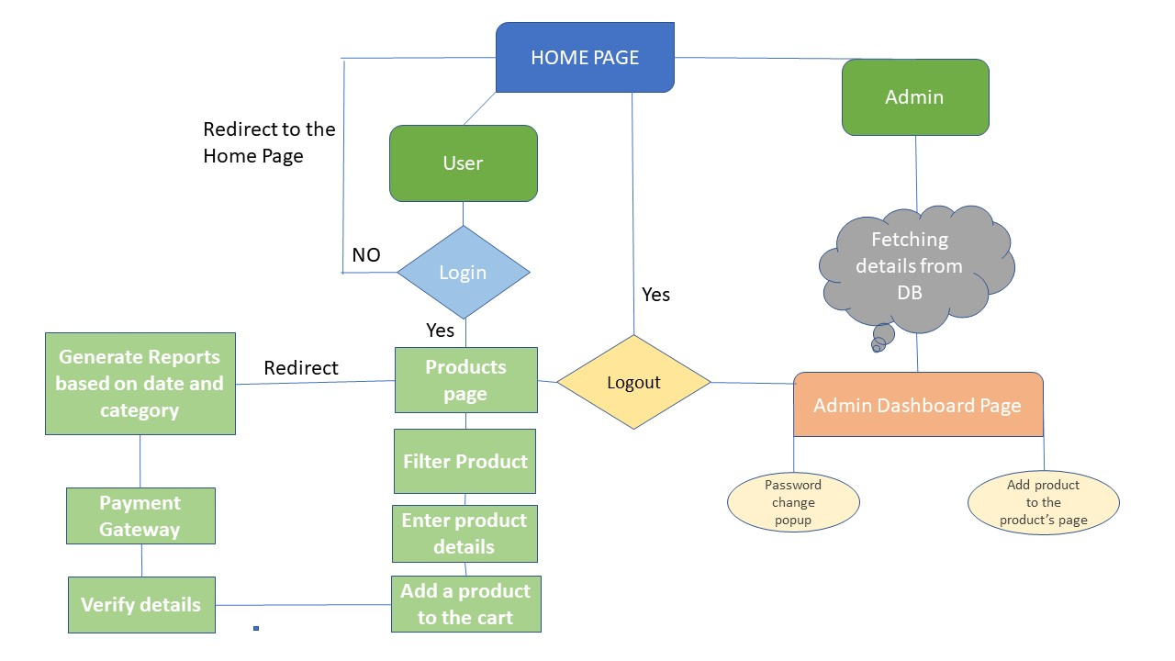

## **Demonstrating the product capabilities, appearance, and user interactions:**

To demonstrate the product capabilities, below are the sub-sections configured to highlight appearance and user interactions for the project.

* Creating the project using Spring Initialize.
* Add the required dependencies and generate the project from Spring website.
* Open Spring Tool Suite Open the Project from the directory and build it.
* Add the required Maven Dependencies in Pom.XML file and build the maven.
* Configure the properties in the application.properties file and run it as spring boot application.
* Pushing the code to the GitHub repository.

## **Unique Selling Points of the Application:**

* This is an E-Commerce Application Designed for various kinds of shoes available.
* The application has functionality of both user view and admin view where the

Admin can manage users and products he can add product and delete product he also can update the product info if required and he can get all the purchase reports of all products purchased by the customer/user.

* The user can login into his account to see the what type of shoes available in the products page he can also filter the product based on the price. The user didn’t have permission to create a product, update and delete the product. The user can have suggestions about product type.

## **Conclusions:**

Further enhancements to the application can be made which may include:

* Separating the role’s for User’s and Admin Part such that the admin

Can manage the website.

* Need to add the Security module for all the validation’s of user and admin by using filters.
* Implement UI Part to make it more Interactive.